**BSOD Detection Script User Guide**

1. Download and install Python.

1.1 Go to browser (E.g. Chrome) and type [python.org](http://www.python.org) to go to the Python official website.

1.2 Under the Downloads section, click on the latest Python version shown to start downloading.

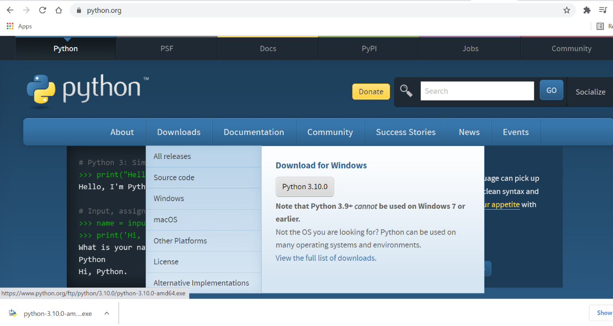1. 3 Click to open the downloaded .exe file to install Python.

1.1

1.2

1.3

1.4 Tick the checkbox below to add the downloaded Python version to PATH.

1.5 Click on the Customize installation.

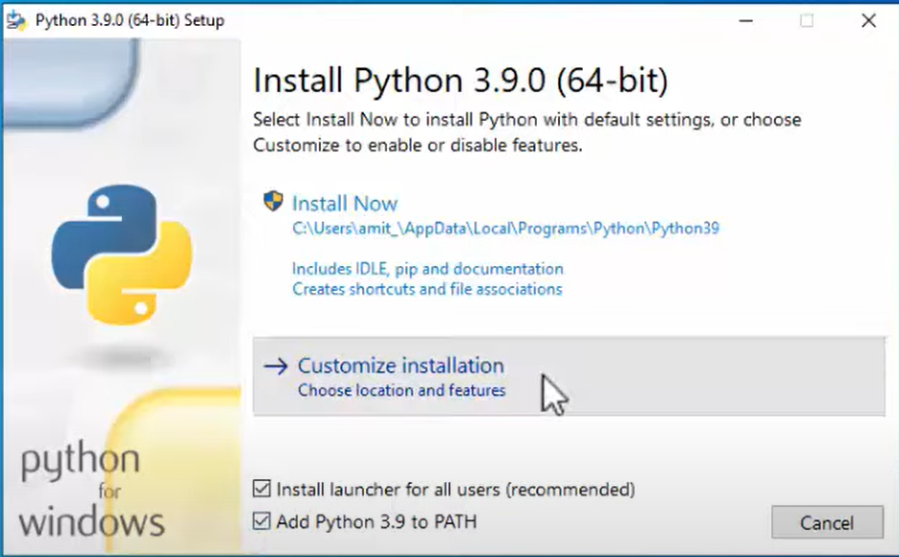

1.5

1.4

1.6 Keep all the default checked Optional Features. Click on Next.

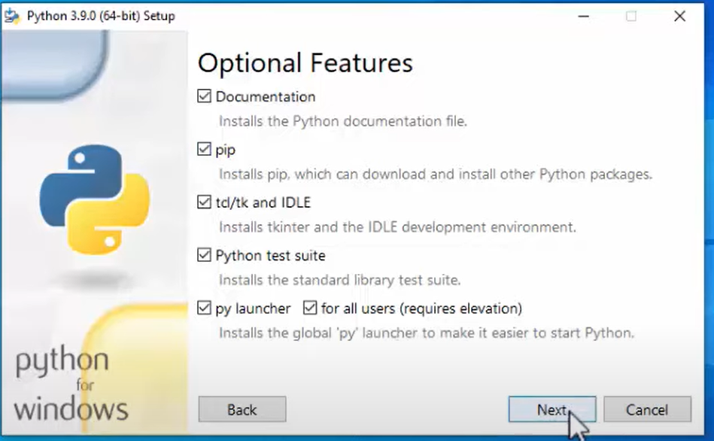

1.6

1.7 In Advanced Options, tick on the Install for all users.

1.8 The default install location will be shown. Click on Install. The installation will take a moment.

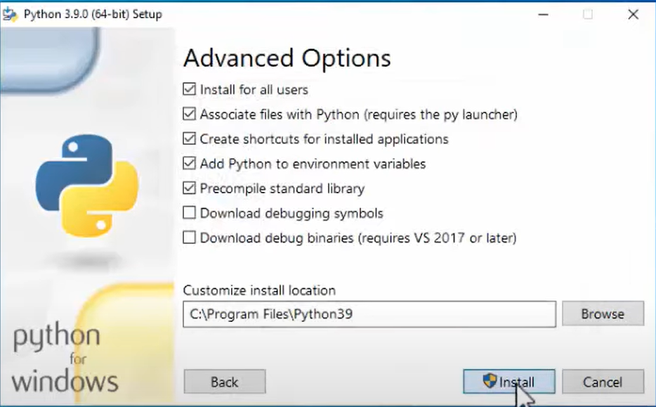

1.7

1.8

1.9 After the installation completed, it'll show Setup was successful. Click on Close. Now, Python is installed successfully.

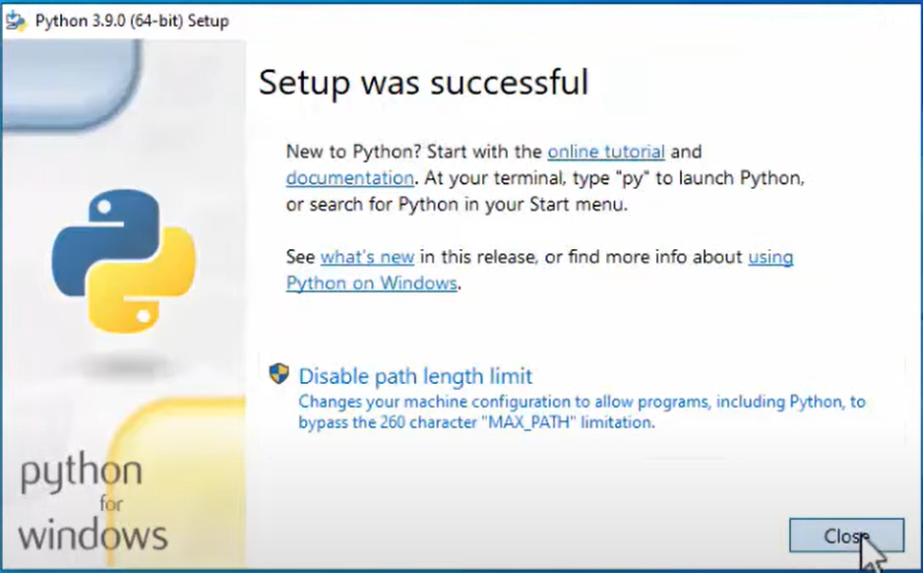

1.9

1.10 To check, go to Start, type cmd, right click on Command Prompt, select Run as administrator.

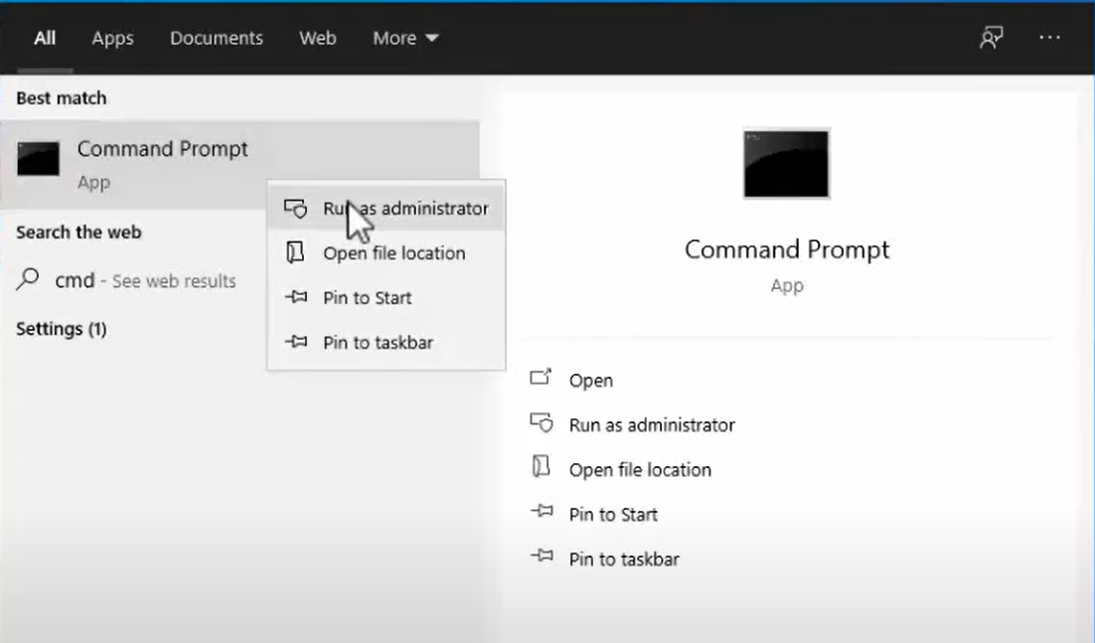

1.10

1.11 Now, the Administrator Command Prompt will be visible. Type **python --version** and click Enter. It'll show the downloaded Python version below.

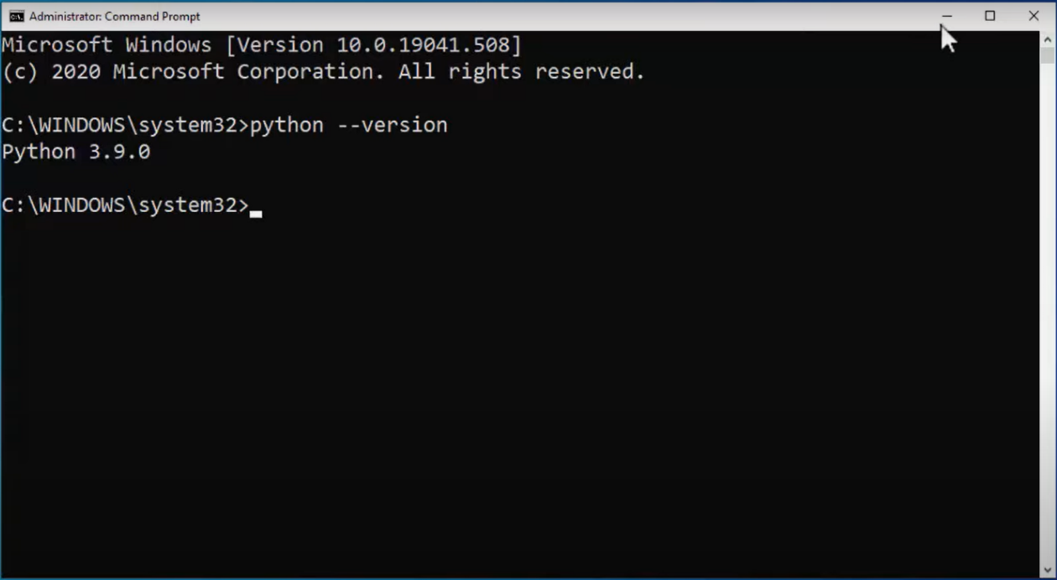

1.11

1. Download and install PyCharm IDE.

2.1 Go to browser (E.g. Chrome) and type [jetbrains.com/pycharm](http://www.jetbrains.com/pycharm/) to go to the PyCharm official website.

2.2 Click on Download.

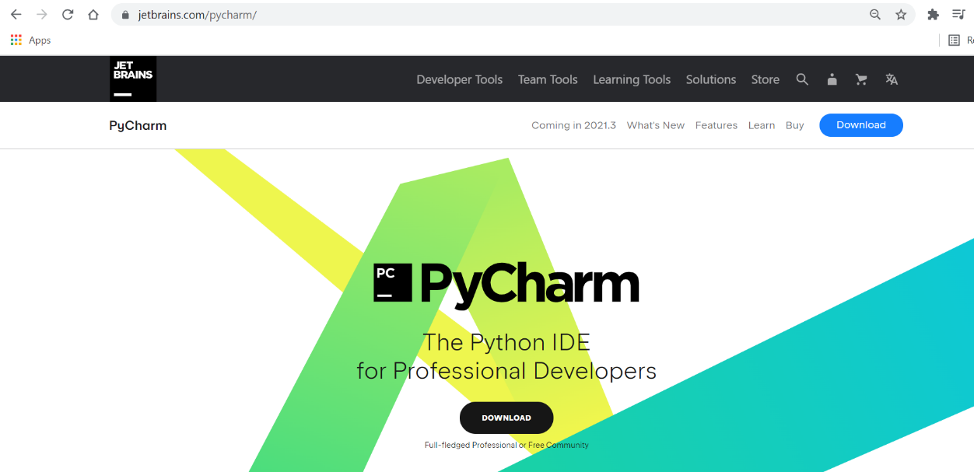 2.1

2.2

2.3 Click on the Download on right to start downloading the Community version.

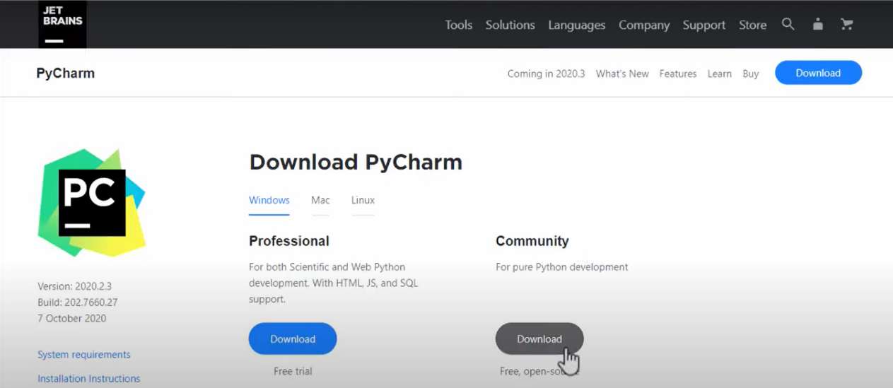

2.3

2.4 Click to open the downloaded .exe file to install PyCharm.

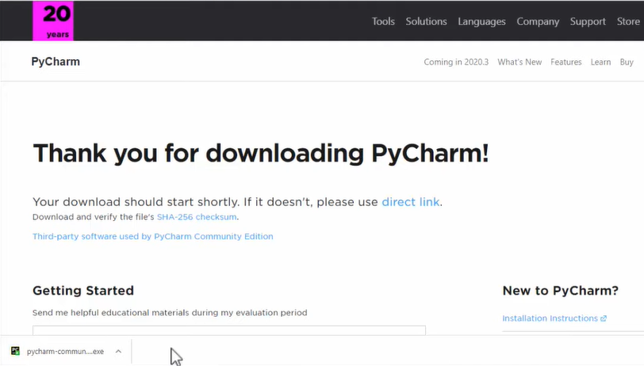

2.4

* 1. Click on Next.

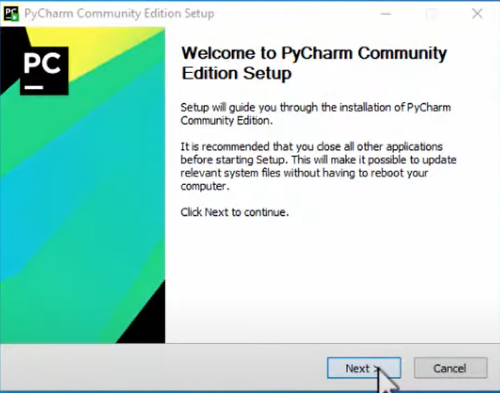

2.5

2.6 The default destination folder path will be shown. Click on Next.

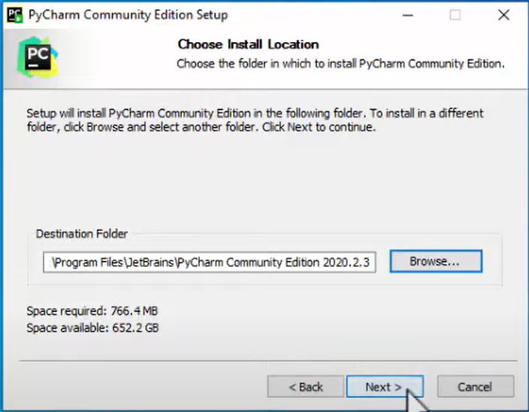

2.6

2.7 The installation options will be visible. Tick 2 checkboxes which are:

- 64-bit launcher

- Add launchers dir to the PATH

2.8 Click on Next.

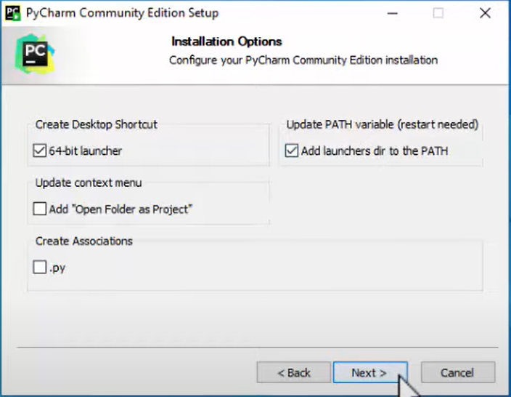

2.7

2.8

2.9 The default Start Menu folder which is JetBrains is already selected. Click on Install. The installation will take a moment.

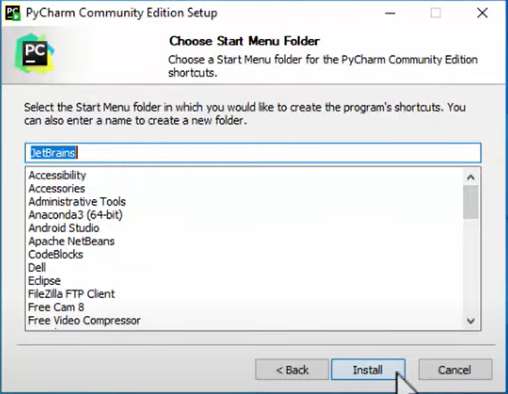

2.9

2.10 Click on Finish to complete PyCharm Community Edition Setup.

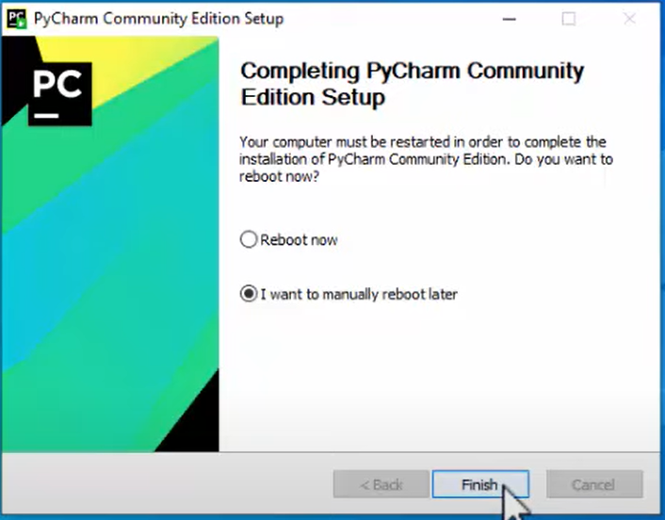

2.10

* 1. Restart your pc.

1. Download the Tesseract windows executable (.exe) file.

3.1 Go to the link given below.

<https://digi.bib.uni-mannheim.de/tesseract/>

3.2 Click the hyper link titled tesseract-ocr-w64-setup-v4.1.0.20190314.exe. to start downloading.

3.3 Click to open the downloaded .exe file to install Tesseract-OCR.

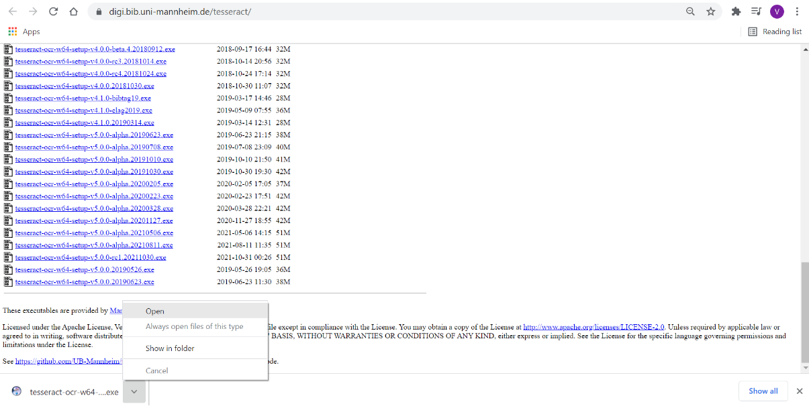 3.1

3.2

3.3

3.4 Windows asks you “Do you want to allow this software to make changes to your system”. Click yes.

3.5 English language is selected by default. Click on OK.

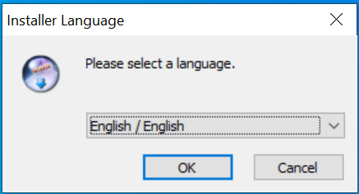

3.5

3.6 The Tesseract-OCR Setup is visible. Click on Next.

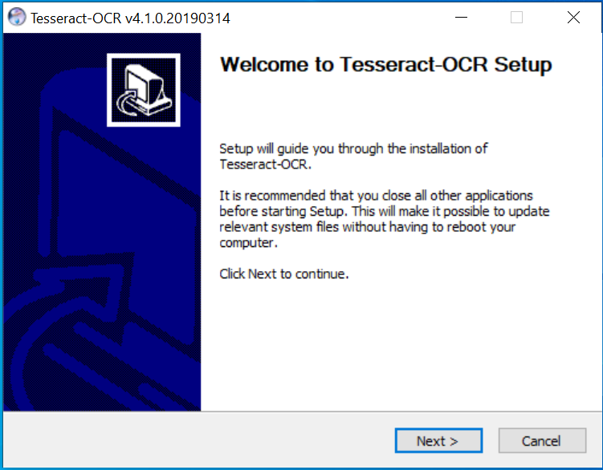

3.6

3.7 The Tesseract-OCR license agreement is visible. Click on I Agree after

reviewing the license terms.

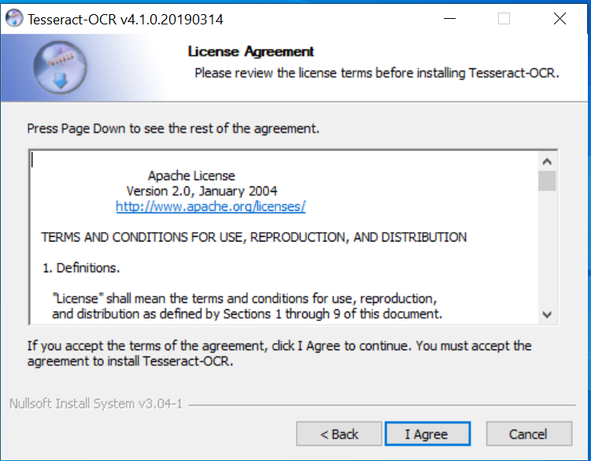

3.7

* 1. Install for anyone using this computer option is selected by default.

Click on Next.

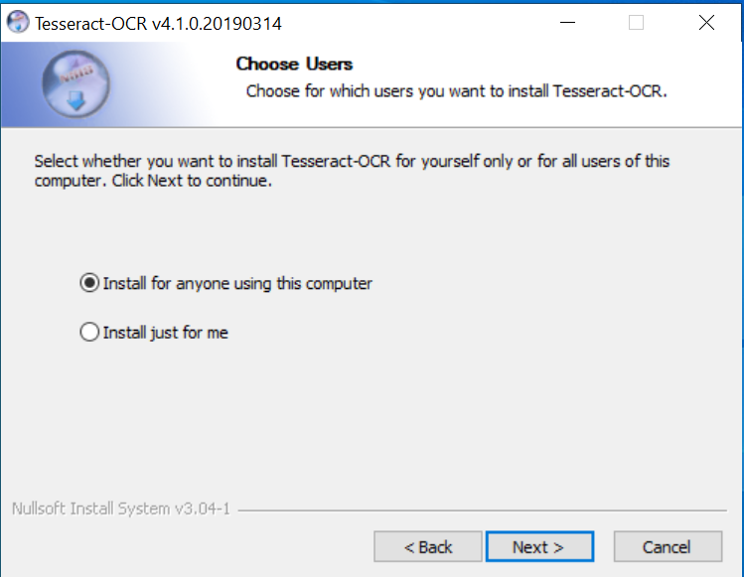

3.8

* 1. “ScrollView”, “Training Tools”, “Shortcuts creation” and “Language data”

should be ticked by default. Click on Next.

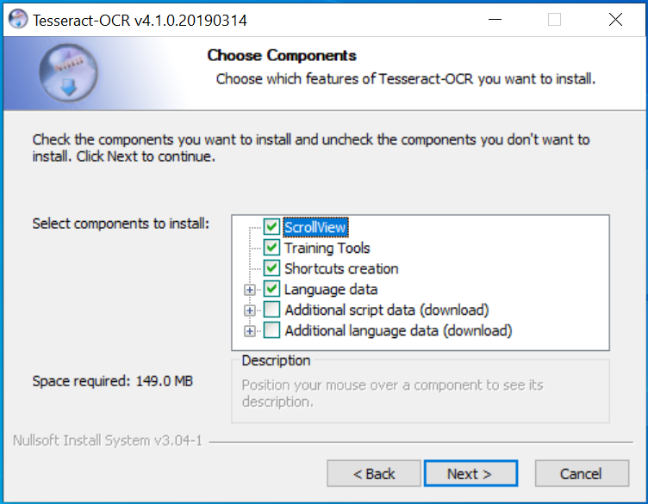

3.9

* 1. The install location shows C:\Program Files\Tesseract-OCR

by default. Click on Next.

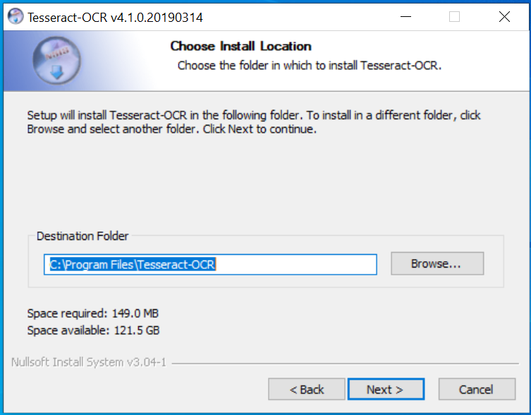

3.10

* 1. Keep the default Start Menu folder name which is Tesseract-OCR.

Click on Install.

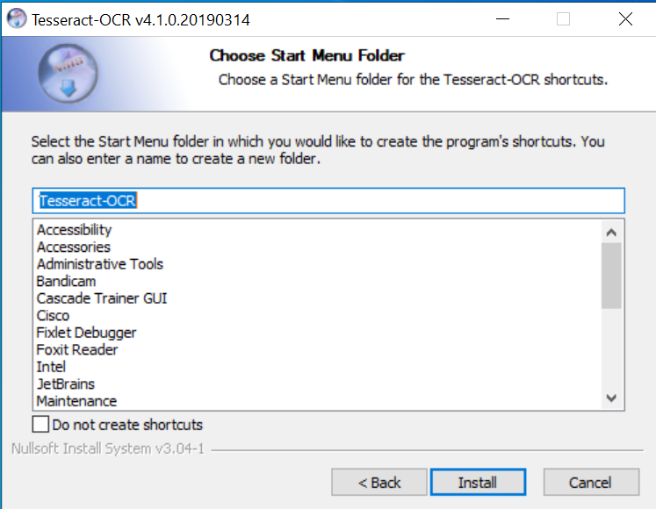

3.11

* 1. Click on Next after the installation is completed.

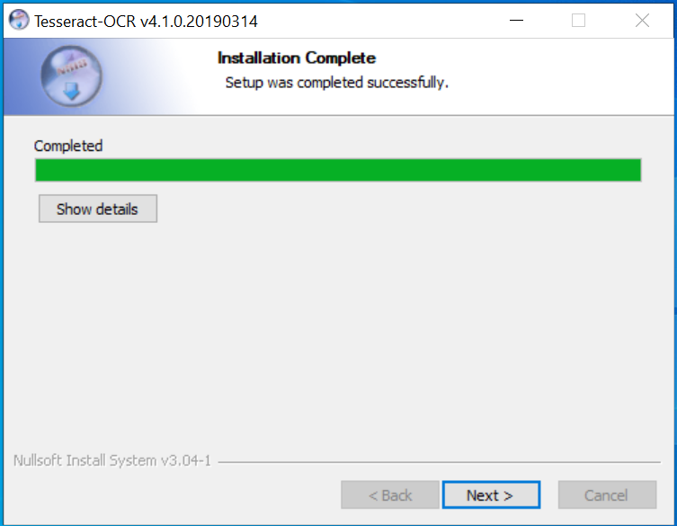

3.12

* 1. Click on Finish.

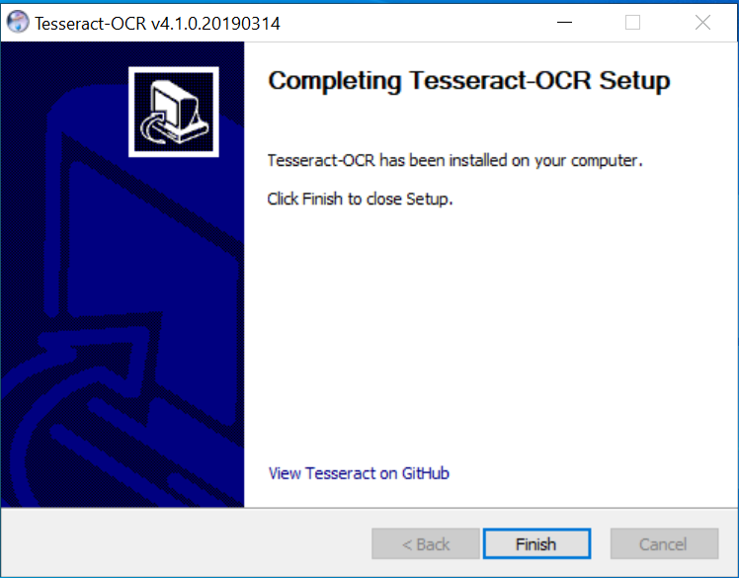

3.13

1. Click to open the PyCharm IDE shortcut visible in the desktop.

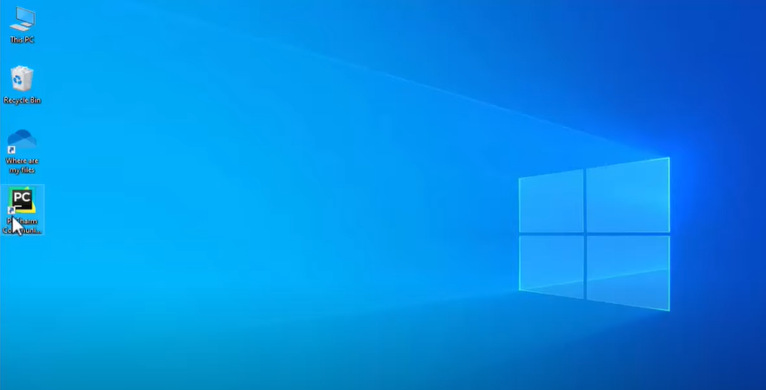

4

1. Do not import settings is selected by default. Click on OK.

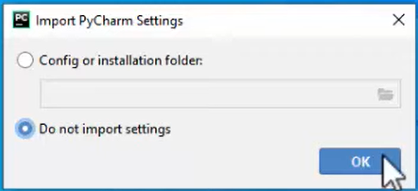

5

1. Click on either Darcula or Light to customize the PyCharm theme.
2. Click on Next: Featured Plugins.

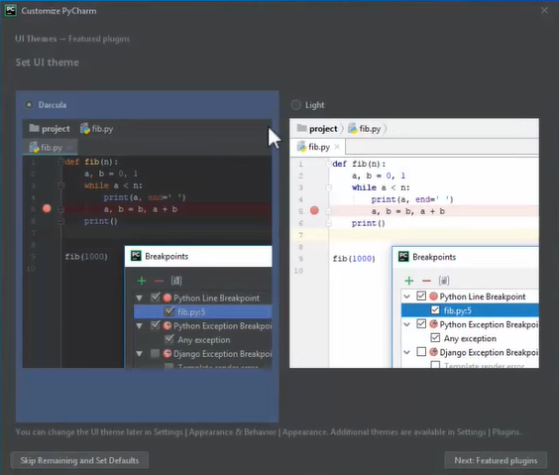

6

7

1. Click on Start using PyCharm.

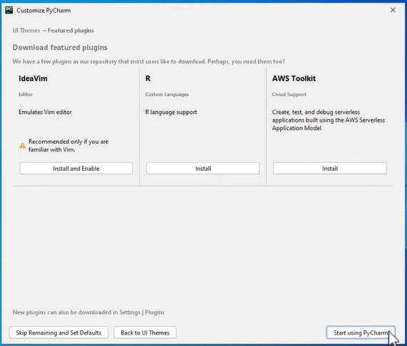

8

1. Click on New Project.

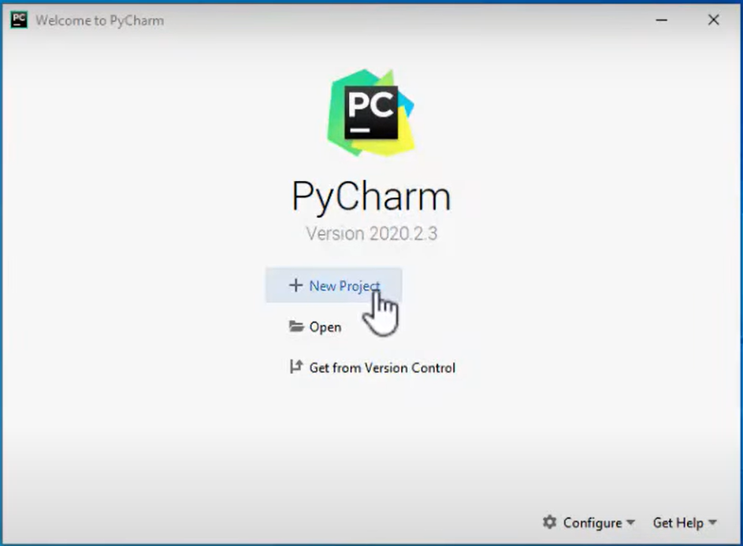

9

1. The pythonProject folder location will be available. Set the name of the pythonProject folder (E.g.: BSOD detection) which is in the PycharmProjects folder.
2. Click on Existing interpreter.
3. If no interpreter in the dropdown list, click on the 3 dots on right.

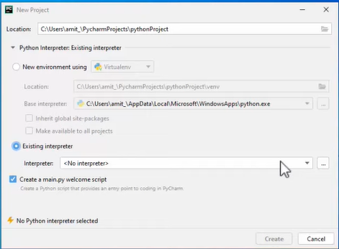 10

11

12

1. Select the System interpreter on left.
2. Click on the interpreter dropdown list and select the path of the downloaded Python .exe file.
3. Click on OK.

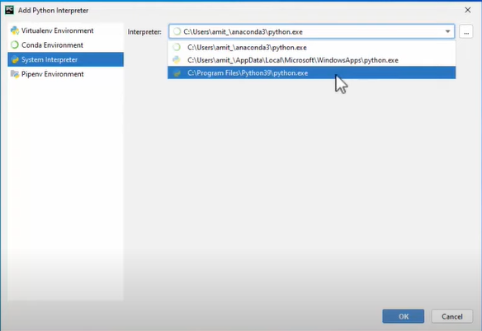

13

14

15

1. Uncheck the checkbox Create a main.py welcome script.
2. Click on Create. Now, the pythonProject folder (E.g. BSOD detection) will be available on left.

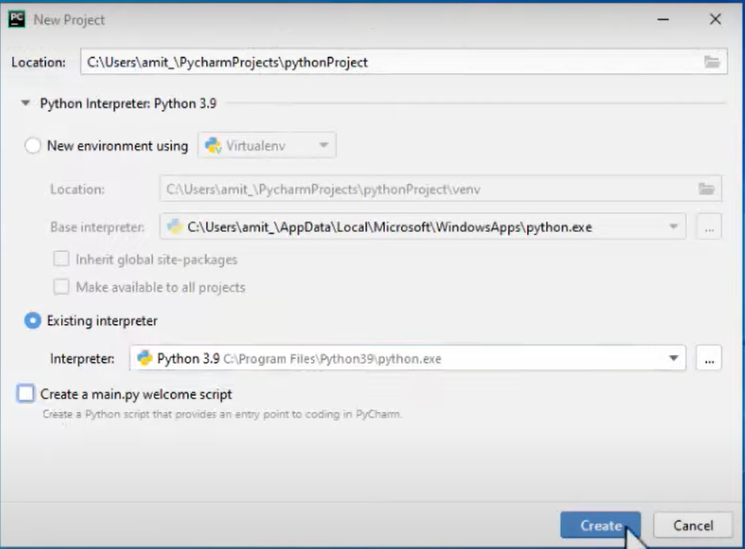

16

17

1. Go to share drive. Find the folder named BSOD detection which contains Images folder, Videos folder and BSOD_detection.py script.
2. Copy and paste the Images folder, Videos folder and BSOD_detection.py script in the pythonProject folder (E.g. BSOD detection).

1. Go to PyCharm. Click to open the BSOD_detection.py script.
2. Install the packages needed to run the BSOD_detection.py script. There are 2 ways to install the packages. You may try whichever method that works better.

**Method 1**

* 1. Click on Terminal below.

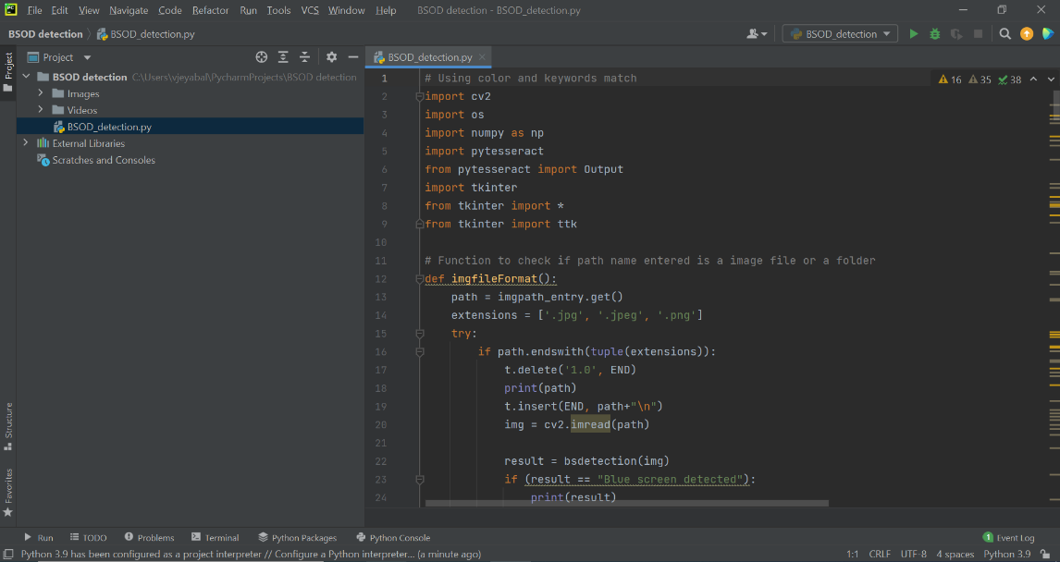

20

21.1

21.2 Under PyCharm terminal, install OpenCV by using the following command: ***pip install opencv-contrib-python***

21.3 Install NumPy in the terminal using the command: ***pip install numpy***

21.4 Install Pytesseract in the terminal using the command: ***pip install pytesseract***

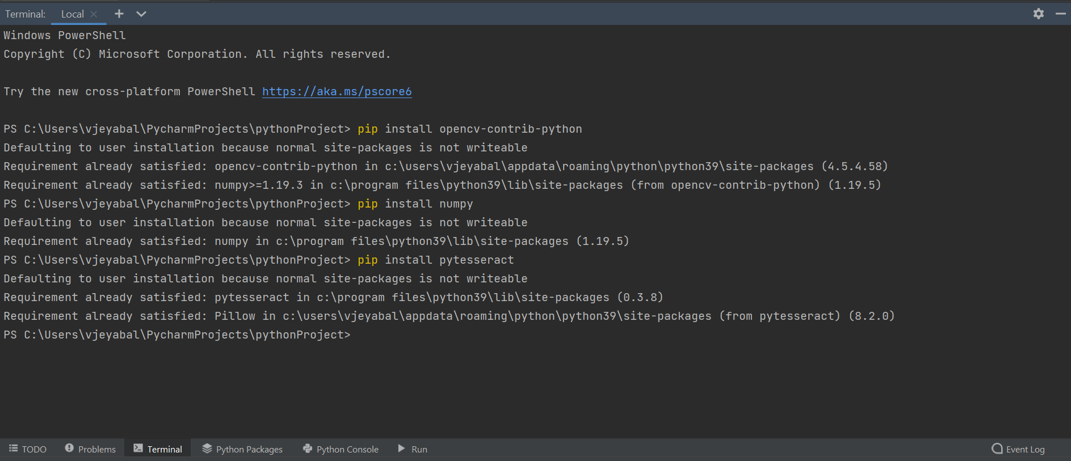

21.2

21.3

21.4

**Method 2**

* 1. Go to File and click on Settings.

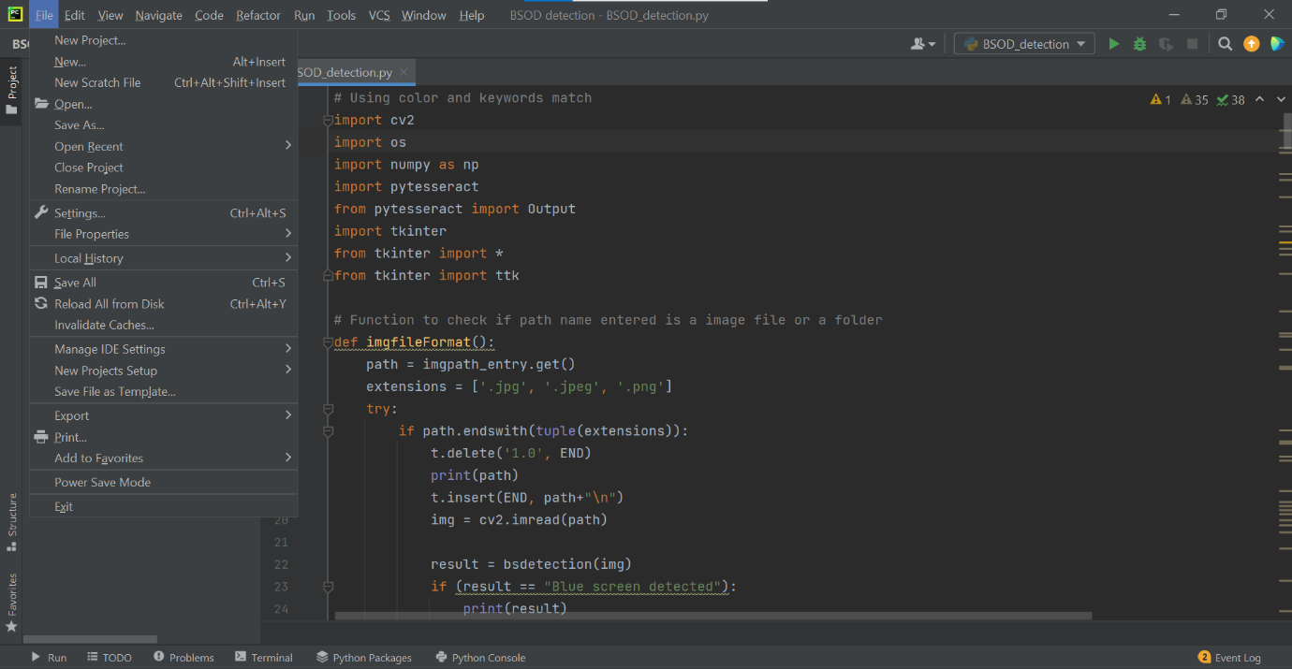

21.5

* 1. Click on Python Interpreter under the BSOD detection project.

21.7 Click on the ‘+’ icon to install packages.

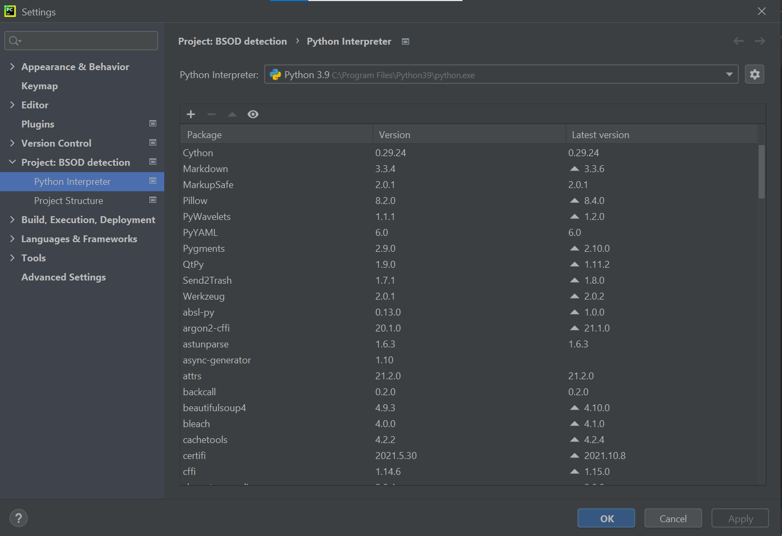

21.7

21.6

21.8 Type the packages name to be installed which are **opencv-contrib-python, numpy** and **pytesseract.**

21.9 Click to select the package and click on Install Package to start installing.

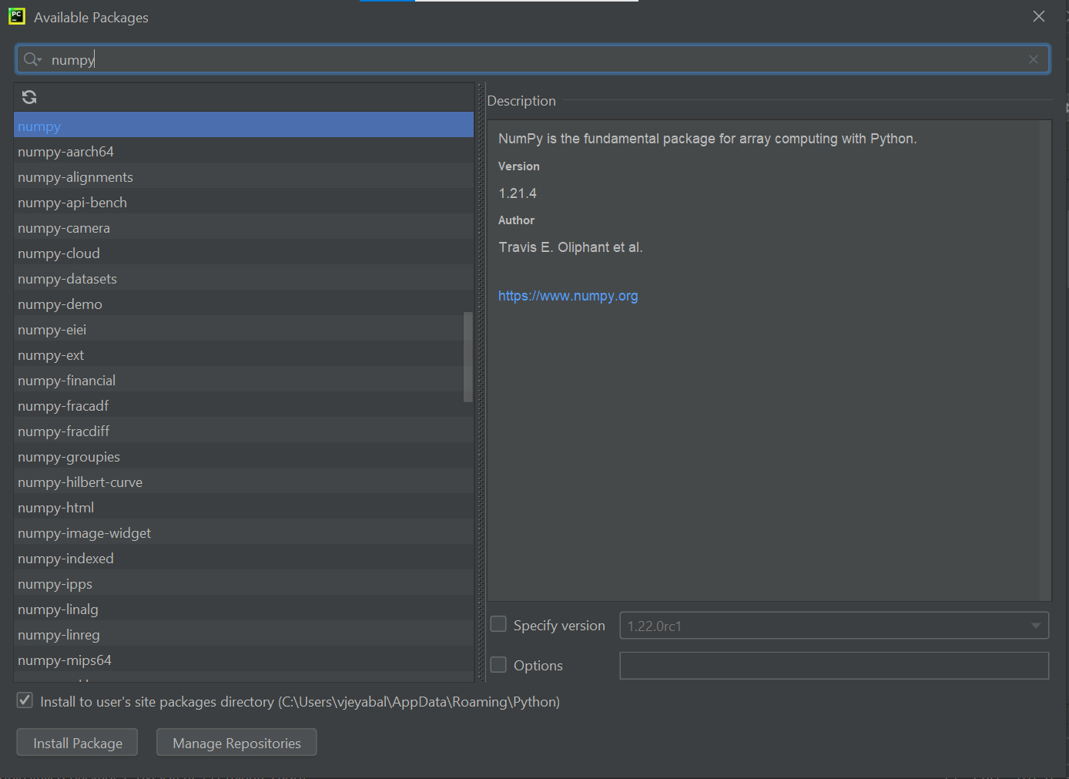

21.8

21.9

21.10 If the packages take too long to be installed and if no information available under the package description, restart your pc and try installing the packages again.

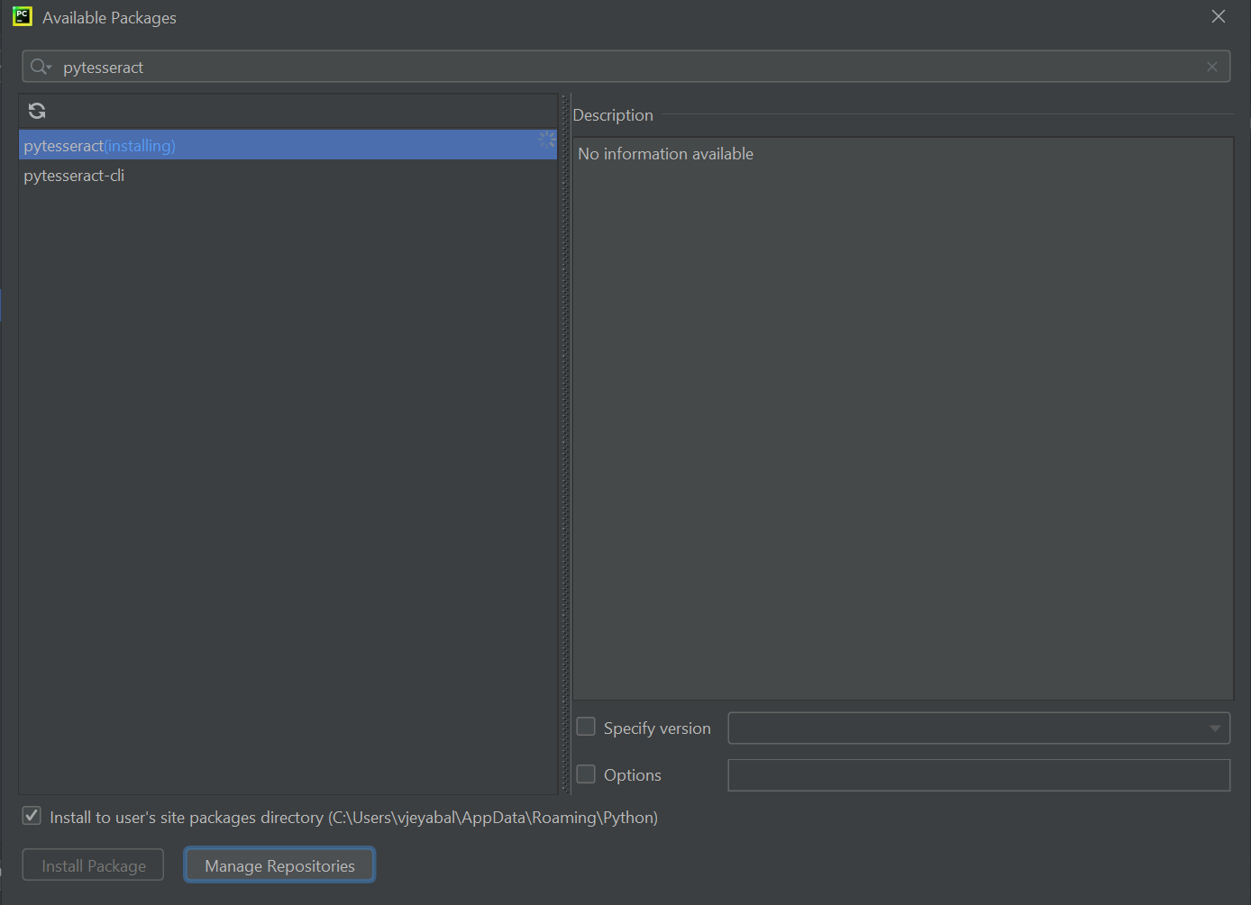

21.10

1. Click 'Run' in the top right to execute the BSOD detection python script. A window will appear.

22 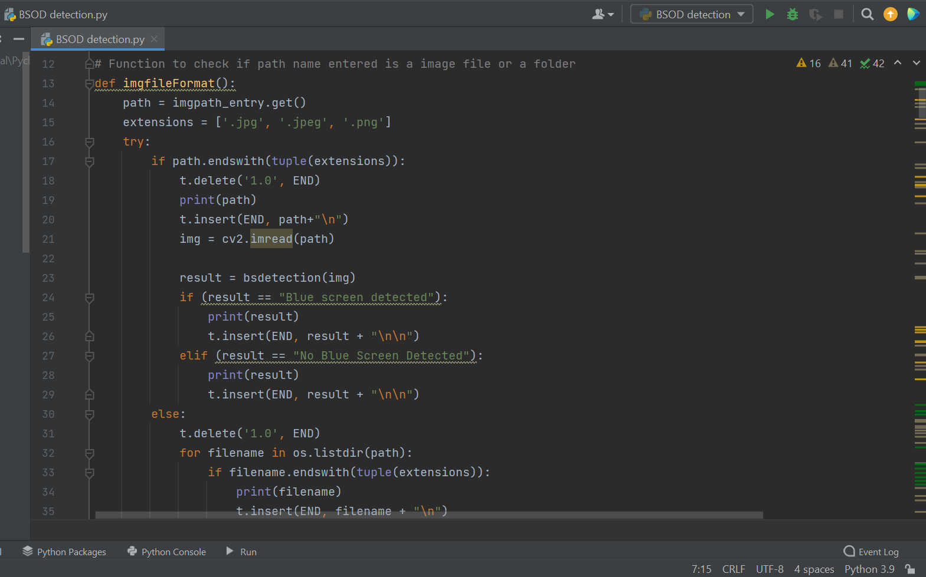

1. Select the file format (Image/Video) by clicking the Radio button.
2. Enter the path of the file or folder (E.g. Images/Videos) based on the selected file format in the File/Folder entry.
3. Click on the 'CHECK' button to start detecting the presence of BSOD in the selected image or video file(s).
4. The latest results will be displayed in the Latest Result textbox. For every wrongly inputted entry, an error message will be displayed in the textbox.
5. Click the 'Refresh' button to clear the content displayed in the textbox.
6. Click the 'Close' button to close the program window and to stop the running program.

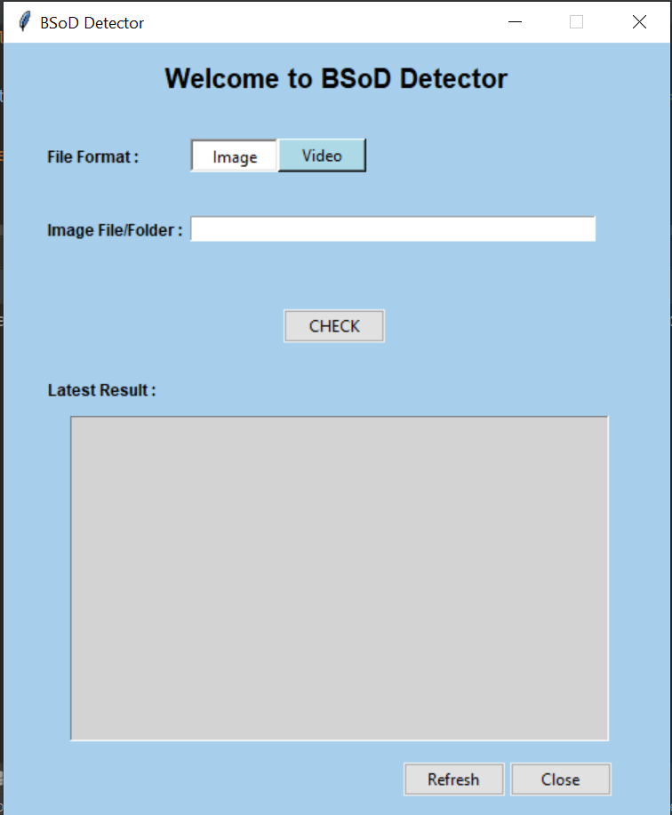

23

24

25

26

27 28